Fibre channel SAN- every computer is connected to a SAN switch to an external RAID device.

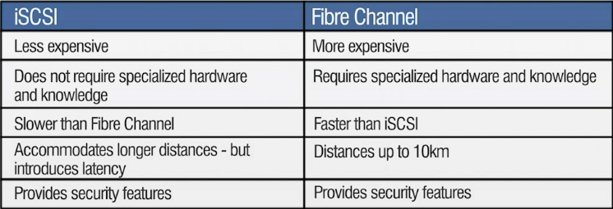iSCSI SAN- Ethernet switch connected to computer through fiber optic to a raid

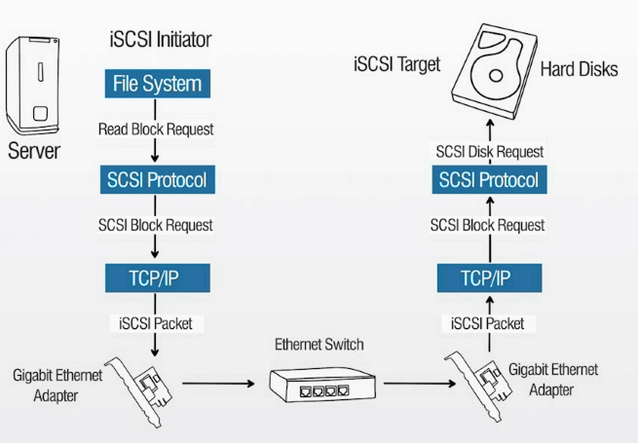

Cluster in a SAN- the users are a signal device and can replace any device that fails

NAS load balancing- speeds up performance by splitting data

NAS clustering- two NAS devices able to recover from a failover

Domain control- back up information

SAN- SCSI protocol

NAS- FTP

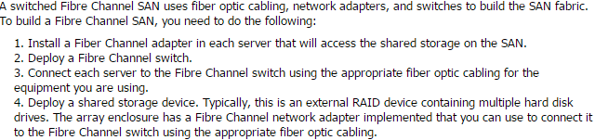

VoIP- less expensive than phone carrier, phones over the internet. Dis adv: inconsistent quality, Echo, Delay, power loss, and special equipment.

Protocols for VoIP- SIP and RTP

SIP- used to maintain, set up and terminate VoIP calls

Switches features used VoIP- VLAN and PoE

PoE- is able to supply power though a switch port

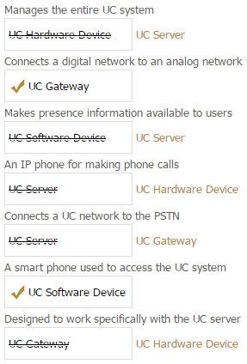

Jitter- when calling someone over VoIP unusual sound effects is called jitter.

1%- packet loss is noticeable in voice traffic

Media Gateway Control Protocol MGCP- VoIP used to interface with the PSTN

Presence information- allows users to know the availability for communication to one and another

Unified communication- integrates calls emails and instant messaging to a signal platform

Session Initiation protocol- used during a call to control process of multimedia communications

Hypervisor- allows virtual machines to interact with the hardware without going through the host operating system

Full Virtualization-completely simulates a real physical host

Virtual switch- virtual machines to communicate with each other

Advantages of virtualization- Centralized administration, and easy migration of system to different hardware

Virtual servers- to provide a DHCP and file services to a physical network

Hypervisor with multiple virtual machines- connect the virtual network interface in the virtual switch, create a new virtual switch configured for host-only networking

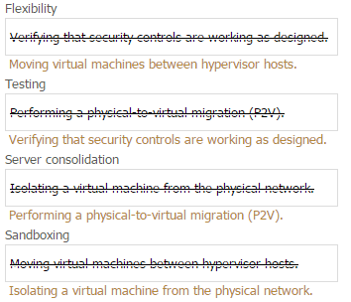

Create a new virtual switch configured for a bridged networking; connect the virtual network interfaces in the virtual machines in the virtual switch.

Virtual router- Multiple networks can be connected to a single interface

Implement a virtual firewall within the hypervisor- to monitor and filter VM to VM

Multiple virtual NIC can be added to a virtual machine, virtual NIC need the appropriate driver installed to function.

Cloud computing eliminates buying duplicate software for each device.

SaaS- delivers software applications to a client either over the internet or on a local area network

PaaS- delivers everything a developer needs to build an application onto the cloud infrastructure

Not True- Cloud computing requires end user knowledge of the physical location and configuration of the system that delivers the services

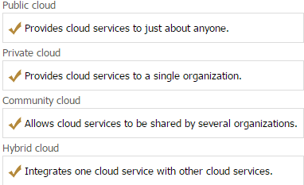

IaaS- infrastructure as a service provides adequate storage and additional

Supervisory control and data acquisition- install the latest firmware updates from the device manufacturer, verify that your network existing security infrastructure is working properly.